GameCube USB-C PD (Power Delivery)
Quick explanation:
The GameCube needs 12V and 3.25 Amps. So, we have 2 options:
1st:
We can use 12V USB-C PD Trigger Module and just solder some wires to the on the GameCube power port but on there is a big chance that the module won’t be giving us 12V but 9V instead because it only supports 20V and 9V even though the USB-C trigger is configured to 12V, so if the charger can’t support 12V it will deliver only 9V which is not enough for the console. So, in the end we need the right adapter every time that delivers 12V. It works but I don’t recommend it.
2nd:
This is the right way to do it, because we are delivering 20V and we are using step down converter we can get the right amps and voltage for the console. And using a step-down converter can provide you with a larger current than the input.
Process Of Wiring:
The wiring is very easy to do, you solder 2 wires from the USB-C PD to the Step-Down Converters input and the converters out directly solder 2 wires to the GameCube’s power pins on the connector.
!!!WARNING DON’T EVER PLUG THE USB-C CABLE AND THE ORIGINAL POWER SUPPLY TOGETHER. THIS WILL FRY YOUR CONSOLE!!!
Parts For GameCube USB-C PD Mod:
XL4015 5A Buck Step Down Converter: https://www.aliexpress.com/item/32213232830.html?spm=a2g0o.cart.0.0.5c9638daOMH0tc&mp=1

USB-C Type-C PD Trigger Module 20V:
https://www.aliexpress.com/item/4001243047536.html?spm=a2g0o.cart.0.0.5c9638daOMH0tc&mp=1

Everything should look like this: 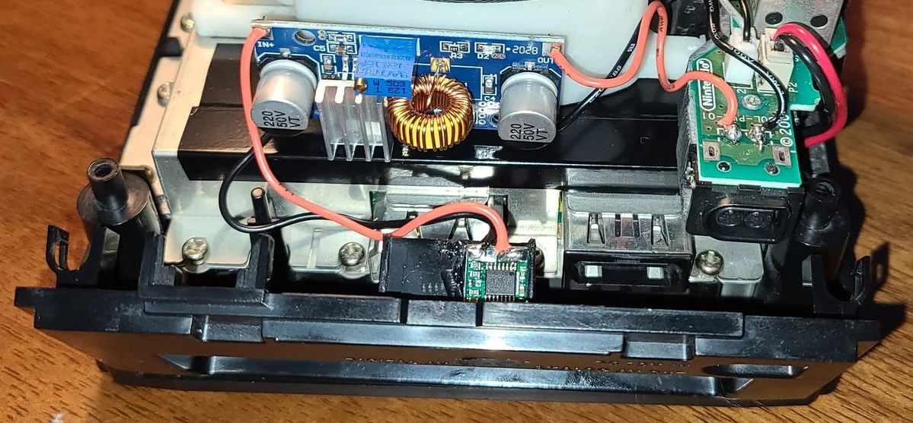
Simple Diagram How To Do It:
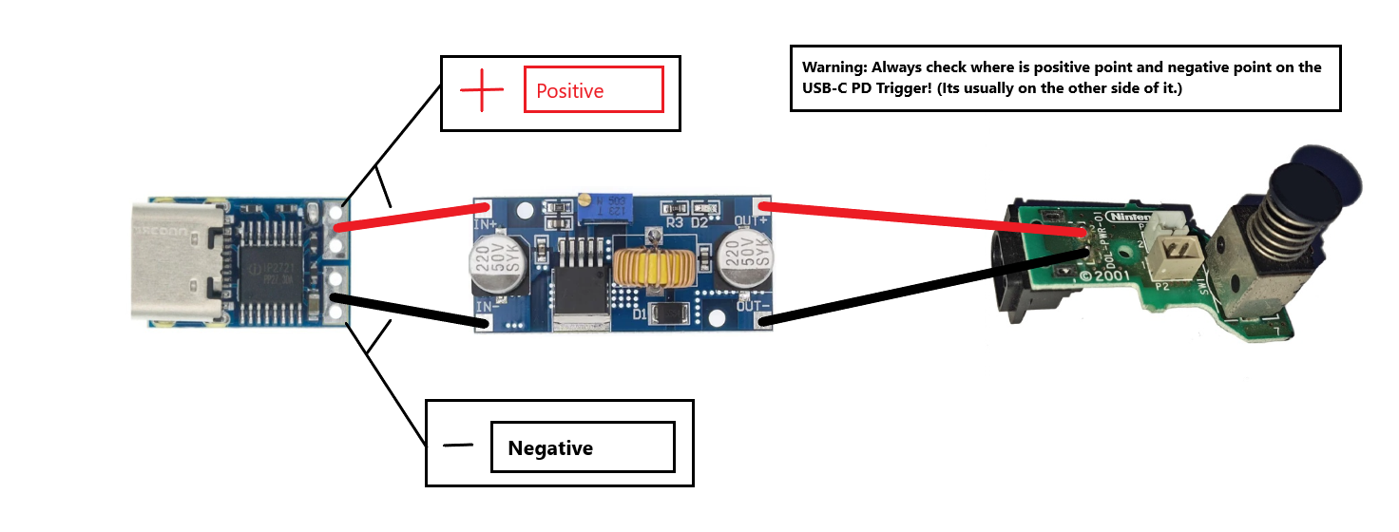
Documented by: u/LOLY_SK: Reddit
Photo (Everything should look like this: ) by: u/onlinewithryan

